

Press release for immediate release

**O-PORT-UNIDADE Port Project kicked off with maximum recognition**

Vale de Mendiz, Douro Valley, 22nd September 2013: For the first time in the history of Port grapes from all over the Douro Valley were put in a lagar[1]. “The participating companies are not only contributing 750 kgs of their top-grapes (equalling one pipe of Port), but also sent their VIP to the lagar to tread the Port.” said Axel Probst from World of Port ([*www.worldofport.com*](http://www.worldofport.com)), the originator of the Project. The profit will be donated to Bagos d’Ouro ([*www.bagosdouro.com*](http://www.bagosdouro.com)), a charity organisation which takes care about the children and youngsters within the Douro Valley.

It all started with a foto-idea. Probst’s current project is a Port book for the German market and he wanted to get the famous faces in the lagar to ensure more “attractiveness of the picture”. Two years and many 100 emails and meetings later it finalised in this unique project. “I received a tremendous support from the producers and institutions, especially from Dirk Niepoort, the Portwine-Institute IVDP and the City of Porto” Probst said.

After the treading distinguished enologists from the Port trade will look after the Port, amongst them Nick Delaforce (Niepoort), Ana Rosas (Ramos Pinto), Antonio Agrellos (Quinta do Noval), Jorge Alves (Quinta Nova, Quinta do Tedo), Jorge Morreira (Real Companhia Velha, Quinta de la Rosa), Francisco „Xito“ Olazabal (Quinta do Vale Meao), Luis Sottomayor (Sogrape), Charles Symington (Symington) and Alvaro van Zeller (Andresen, Barao de Vilar). “The timing of this event was absolutely superb. The grapes were in perfect condition for this year“ stated Noval’s enologist Antonio Agrellos. “With these excellent grapes and this enologist team I am very optimistic to produce a very special Port” says Probst.

Additional information about the project can be found at [*www.o-port-unidade.com*](http://www.o-port-unidade.com)

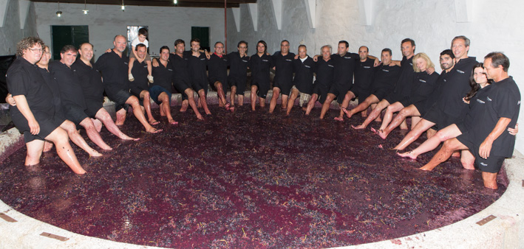

Foto: The best ports are still made in the lagar: Dirk Niepoort (Niepoort), Antonio Agrellos (Quinta do Noval), Antonio Saraiva (Rozes), Jorge Dias (Dalva), George Sandeman (Sandeman), Charles and Martin Symington (Symington), Francisco Ferreira (Quinta do Vallado), Miguel Roquette (Quinta do Crasto), Oscar Quevedo (Quevedo), Manuel Cabral (IVDP), Carlos Flores (Andresen), Tiago Alves de Sousa (Alves de Sousa), Jorge Manuel Pintao (Pocas), Joao Roseira (Quinta do Infantado), Joao Nicolau de Almeida (Ramos Pinto), Paulo Coutinho (Quinta do Portal), Pedro Sa (Vallegre), Manuel Silva (Rozes), Jorge Borges (Pintas), Sophia Bergqvist (Quinta de la Rosa), Pedro Silva Reis (Real Companhia Velha), Antonio Amorim (Quinta Nova), Luisa Olazabal (Quinta do Vale Meao) and Luis Sottomayor (Ferreira)

1. Lagar is a mostly a granite pond where the grapes are put in and crushed either traditional by human feet or automatic with a so called robotic lagar.